1. **Some information of engineering process：**

a. We are using the module with the nRF52832 chip, the SDK package is :nRF5_SDK_15.3.0

b. Softdevice Dive: ANT_s332_nrf52832_6.1.1.hex

c. Reference file：examples\ant\ant_multi_channels\rx\pca10040\s212\arm5_no_packs和

\examples\ant\ant_plus\ant_bpwr\bpwr_rx\pca10040\s212\arm5_no_packs

**2、The current problem is:（Receiving is ：Console， Transferring is：ANT Power crank）**

When ANT open one channel ant_bpwr receiving function, sometimes causes randomly not receiving data in a 20 minutes workout. When we open the multiple channels, for example, 10 channels, open ant_bpwr receiving function, it is easier to not receiving data, average for 5 minutes drop out for once, the longest for not getting data is 17 seconds, and the minimum is 2~3 seconds. What is the reason for causing so easily not receiving data?

Below picture is our initially engineering parameters：（Reference file are：examples\ant\ant_multi_channels\rx\pca10040\s212\arm5_no_packs\

&

examples\ant\ant_plus\ant_bpwr\bpwr_rx\pca10040\s212\arm5_no_packs

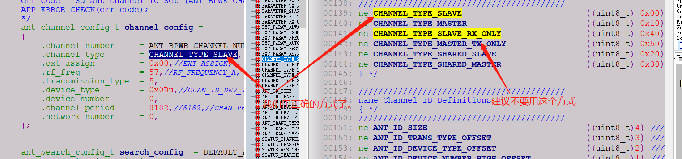

**我們用正確的方式了🡪**We are using the correct method.

**建議不要用這個方式🡪**The recommendation for us is not using this method.

**Event report processing：**

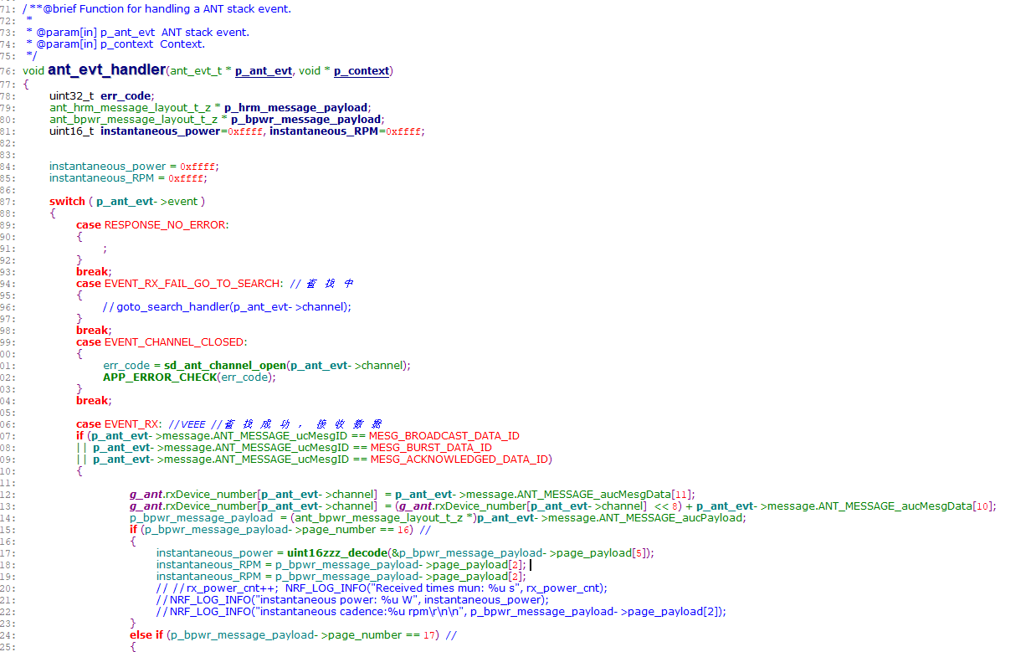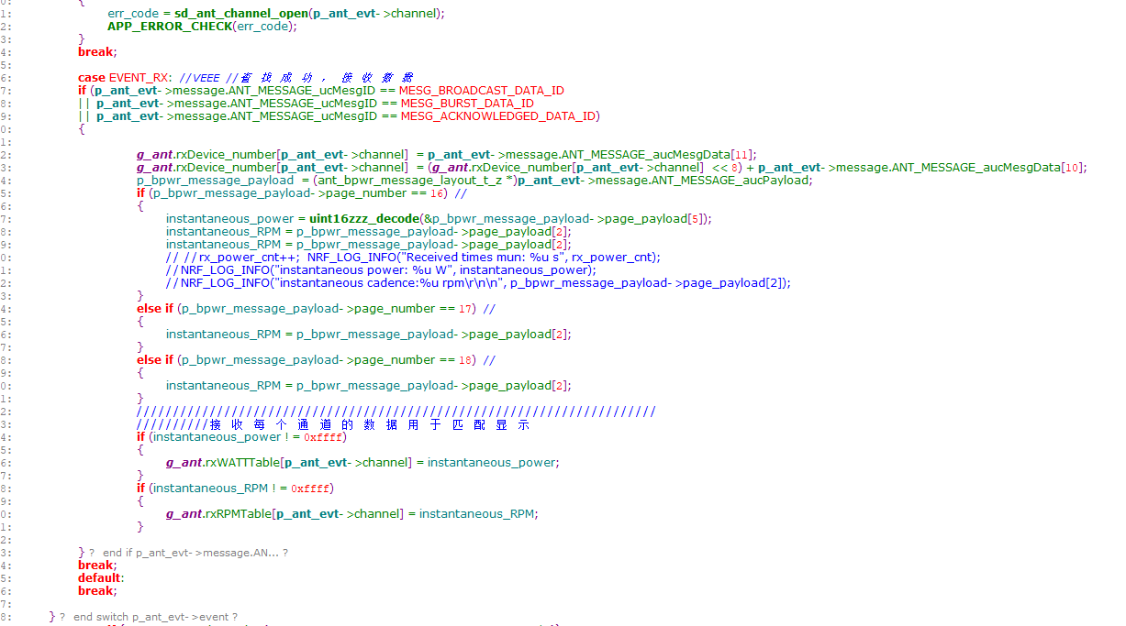

1. **When the issue is happened, we start to deal with and find some explaining documents on ANT website. About some Dithering, Channel period message, can you please guide me if my direction is right?**

If it’s right direction, I would like to ask two questions:   
1. How to integrate the Dithering? Can we have some sample code for reference?

2. How to integrate or adjust the channel period? Can we have some sample code for reference?

1. **Then we found some ANT document, the content file describes: when the process of the ANT communicate, the data drop out too much then will dynamically adjust the fail,.**

**IS it a specific method in ANT protocol? Which side should do this method? Is it ANT protocol or the API usage?**

**The attachment is what we print the log, please check for us:**

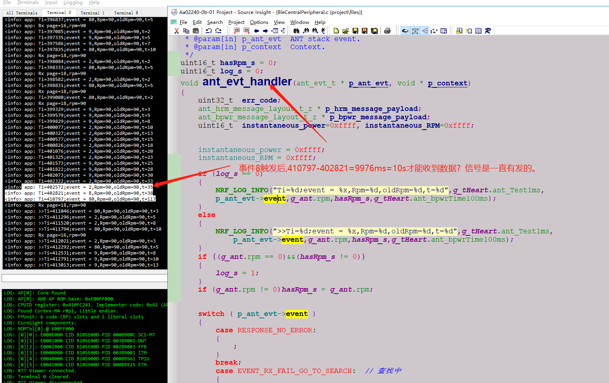

**事件觸發後,410797-402821=9976ms=10s才能收到數據? 信號是一直有發的

🡪**The event 410797-402821=9976ms=10s, then the console can receive the data, but the signal seems it always been sent.